Coal Tar Asphalt Driveway Sealer
Technical DATA and MSDS Information
http://store.asphaltkingdom.com/supply-store.html
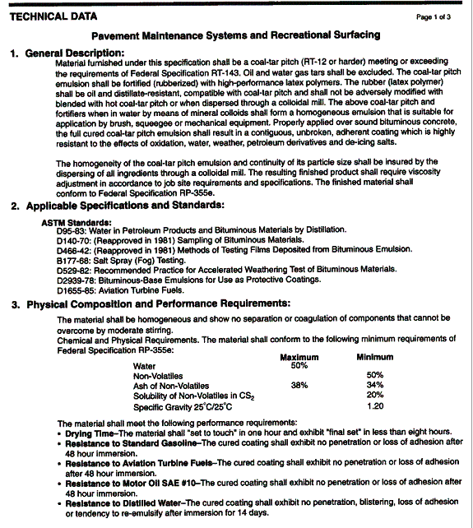
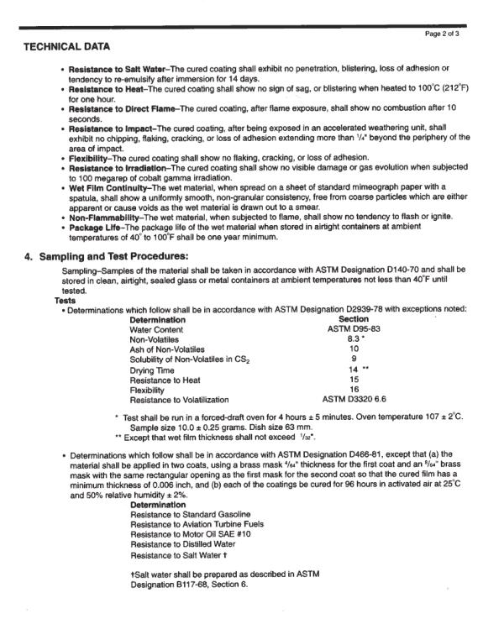

MATERIAL SAFETY DATA SHEET
In compliance with the Superfund Amendments and Reauthorizations Act (SARA Title III, section 313), Federal Hazard Communications Regulations (WHMIS and OSHA CFR 1920:1200), and with interest of informed use of our product, we are providing you with this Material Safety Data Sheet.
In the events that you are not the person who needs this information, please direct this MSDS to the person responsible for safe handling, disposal, and storage of products in your company.
All employees, agents, contractors, customers, or others who may handle this product should be familiar with any warnings of precautionary procedures related to this product and to materials made from it.
This MSDS will be updated regularly to reflect the most recent information in our possession. Please ensure that obsolete MSDS sheets in your file of this product are discarded.

SECTION I – PRODUCT IDENTIFICATION
PRODUCT NAME:SealPave Driveway Sealer
MANUFACTURER NAME: SurfaceCoatingsCompany/Loyalty International Limited
EMERGENCY PHONE NUMBER: 866-399-5562
AFTER 5 PM AND ON WEEKENDS: 866-399-5562
ORIGINATOR: R.A.H.
TRADE NAMES & SYNONYMS: Pavement Maintenance Coating
CHEMICAL FAMILY: N/A
EFFECTIVE DATE: 8/31/99
DATE SUPERSEDED: 5/1/05

SECTION II – HAZARDOUS INGREDIENTS

Coal Tar Pitch

CAS #65996-93-2
% by weight: 30-33%
Listed in SARA Title III, Section 313: No
OSHA PEL: 0.2 mg/m3 (volatiles)
ACGIH TLV: 0.2 mg/m3 (volatiles)
STEL: N/A
LC50 : N/A
LD50: N/A

Clay

CAS #1332-58-7
% by weight: 17-20%
Listed in SARA Title III, Section 313: No
OSHA PEL: 5 mg/m3 (dust)
ACGIH TLV: 2 mg/m3 (dust)
STEL: 5 mg/m3 (dust)
LC50: N/A
LD50: N/A

Water

CAS #7732-18-5
% by weight 45-50%
Listed in SARA Title III, Section 313: No
OSHA PEL: N/A
ACGIH TLV: N/A
STEL: N/A
LC50: N/A
LD50: CTI>320.000
N/A = Not available or applicable
Ingredients total weight % are below 100% only if all others unlisted are not considered hazardous
by any federal (OSHA, WHMIS, SARA), any state or province, or local Right-To-Know regulations.

SECTION III – PHYSICAL DATA

APPEARANCE & ODOR: Black or brownish black liquid with tar odor
BOILING POINT: 212° F
VAPOR PRESSURE: 25mm Hg
SPECIFIC GRAVITY: 1.0-1.3 PHYSICAL STATE: Liquid
SOLUBILITY IN WATER: Miscible FREEZING POINT: 32° F
EVAPORATION RATE: 1 % VOLATILE (by wt.): 50-53%
PH: 6.5-8.0 THRESHOLD ODOR: N/A
WATER/OIL DIST. COEFFICIENT: 1/1 VAPOR DENSITY: 1

SECTION 1V – FIRE AND EXPLOSION HAZARD DATA
FLAMABILITY CLASSIFICATION: Not regulated
FLASH POINT: N/A AUTO IGNITION TEMP: N/A
LOWER EXPLOSIVE LIMIT (LEL): N/A
UPPER EXPLOSIVE LIMIT (UEL): N/A
COMBUSTION PRODUCTS:
Hydrocarbon compounds, CO2 and CO.
EXTINGUISHING MEDIA:
Foam/dry chemical/carbon dioxide
SPECIAL FIRE FIGHTING PROCEDURES:
Cool exposed containers to prevent steam pressure build up. Wear self-contained breathing equipment.
UNUSUAL FIRE AND EXPLOSION HAZARDS:
Containers may rupture due to steam pressure.
NFPA RATING: HEALTH: 2: FIRE 1: REACTIVITY: 0
UN/NA/PIN#: N/A
IMPACT SENSITIVE: No
STATIC SENSITIVE: No
EXPLOSIVE POWER: N/A
BURNING RATE: N/A

SECTION V – HEALTH HAZARD DATA
THRESHOLDLIMIT VALUE: See Section II
ROUTES OF ENTRY: Skin, eyes, inhalation, ingestion.
EFFECTS OF OVEREXPOSURE:
Eyes: May cause eye irritation which in the absence of recommended first aid
may result in severe burns.
Inhalation: May cause headaches and nausea. Prolonged and repeated inhalation
may be harmful to respiratory system.
Skin: May cause irritation of skin or more harmful effects. When not washed off accentuated by sunlight,
skin contact with the product volatiles may result in burns which may be severe.
Ingestion: May cause nausea, cramps, vomiting, diarrhea or acute effects. May be fatal in large amounts.
UNUSUAL CHRONIC TOXICITY:
May cause cancer of the skin, lungs, kidney, or bladder. Prolonged or repeated
contact over many years in the absence of good hygiene and personal protection
may lead to changes in skin pigmentation and skin tumors.
CARCINOGENIC:
Yes, listed in IARC, ACGIH, and NTP. WARNING: Using this product will expose you to a chemical
known to the state of California to cause cancer.
EMERGENCY AND FIRST AID PROCEDURES:
Eyes: Immediately flush with plenty of water for 15 minutes and call a physician.
Inhalation: If affected, remove to fresh air.
Skin: Wash thoroughly with plenty of water and soap.
Ingestion: Seek physician immediately, show MSDS or label, DO NOT induce vomiting.

SECTION VI – REACTIVITY DATA
STABILITY: Stable
CONDITIONS TO AVOID: Keep from freezing.
INCOMPATIBILTY (materials to avoid): Strong oxidizing agents.
HAZARDOUS POLYMERIZATION: Will not occur.
HAZARDOUS DECOMPOSITION PRODUCTS: N/A
CONDITIONS TO AVOID:N/A

SECTION VII – SPILL OR LEAK PROCEDURES
SARA TITLE III:
# 302: No # 304 CERCLA: No #313: Yes RCRA: No
STEPS TO BE TAKEN IN CASE MATERIAL IS RELEASED OR SPILLED:
Ventilate the area. Wear suitable protective clothing, gloves & eye/face protection. Contain and pick up waste materials.
Put in a sealed approved container. Dispose of in accordance with federal, state and local regulations.
WASTE DISPOSAL METHOD: Dispose in accordance with Federal, State and Local Regulations.
REPORTABLE QUANTITES (lbs): N/A TPO (lb): N/A
REGULATIONS: WHMIS, SARA, state and province HAZARDOUS WASTE:n/a

SECTION VIII – PRECAUTIONS FOR SAFE HANDLING AND USE
VENTILATION:
Local Exhaust: Required
RESPIRATORU PROTECTION:
Use only with adequate ventilation. If ventilation is inadequate, wear approved respiratory equipment.
PROTECTIVE GLOVES: wear rubber gloves.
EYE PROTECTION: wear safety glasses, goggles, or face shield.
OTHER PROTECTIVE EQUIPMENT: wear suitable protective clothing.
ESTIMATED LD50. MG/KG: N/A
ESTIMATED LC50: N/A
SENSITIZATION: N/A
IRRITATION: Yes

SECTION IX – REGULATORY INFORMATION
Keep out of reach of children.
For professional and industrial use only.
Always read label plus precautions and follow directions carefully.
Keep from freezing.
Avoid contact with eyes, skin and clothing.
Wear suitable protective clothing, gloves and eye/face protection.
Wash thoroughly after using.
Do not breath vapor or spray mist.
Use only in well ventilated areas.
Keep containers closed when not in use.
DO NOT TAKE INTERNALLY.
Additional Technical Data Sheets and/or MSDS area available upon request.
THE INFORMATION AND RECOMMENDATIONS PROVIDED HEREIN ARE BELIEVED TO BE
ACCURATE AS OF THE DATA HEREOF. HOWEVER, SUCH INFORMATION AND RECOMMENDATIONS
ARE PROVIDED WITHOUT WARRANTY OF ANY KIND AND THIS CORPORATION DISCLAIMS ANY AND
ALL LIABILITY OR LEGAL RESPONSIBILITY FOR USE OR RELIANCE UPON SAME.

